

Promilo- Data analysis & recommendation

BA Assignment



***By:*** *P B Sandeep*

***Email****:* [*anithasandeep8@gmail.com*](mailto:anithasandeep8@gmail.com)

**Promilo – Data Analysis and** **Insights for different page Optimization**

This comprehensive analysis examines user acquisition, engagement patterns, and optimization opportunities for Promilo with over 25,000 users globally. The dataset reveals critical insights for improving app performance, user retention, and revenue generation in the competitive market.

**Key Findings:**

* **Total User Base**: 22,872 new users with 41,164 engaged sessions
* **Geographic Concentration**: 98% of users from India, with Bengaluru leading at 6,097 users
* **Acquisition Performance**: Display advertising dominates volume (9,957 users) but Organic Search shows highest engagement (81.4%)
* **Conversion Challenges**: Significant drop-offs identified at login (27.7%) and content consumption (12.1%) stages
* **Marketing Efficiency**: $301,337 total ad spend with $12.41 average cost per conversion. (*The cost and pricing is assumed approx. & after data analysis*)
* **Demographic Gaps**: 54% of users have unknown age data, indicating data collection opportunities.

**Data Analysis & Recommendations:**

**Data Exploration:**

The dataset consisted of multiple sheets, including **User Acquisition, Traffic Acquisition, Event Report, Conversion Report, Pages & Screens Report, Demographic Report, City-wise Report, Gender Report,** and more. Many of these sheets required extensive cleaning, where I worked on removing null values and carefully deciding whether to retain or exclude “(not set)” values based on their relevance.

**User Acquisition Analysis:**

**Channel Performance Assessment:**

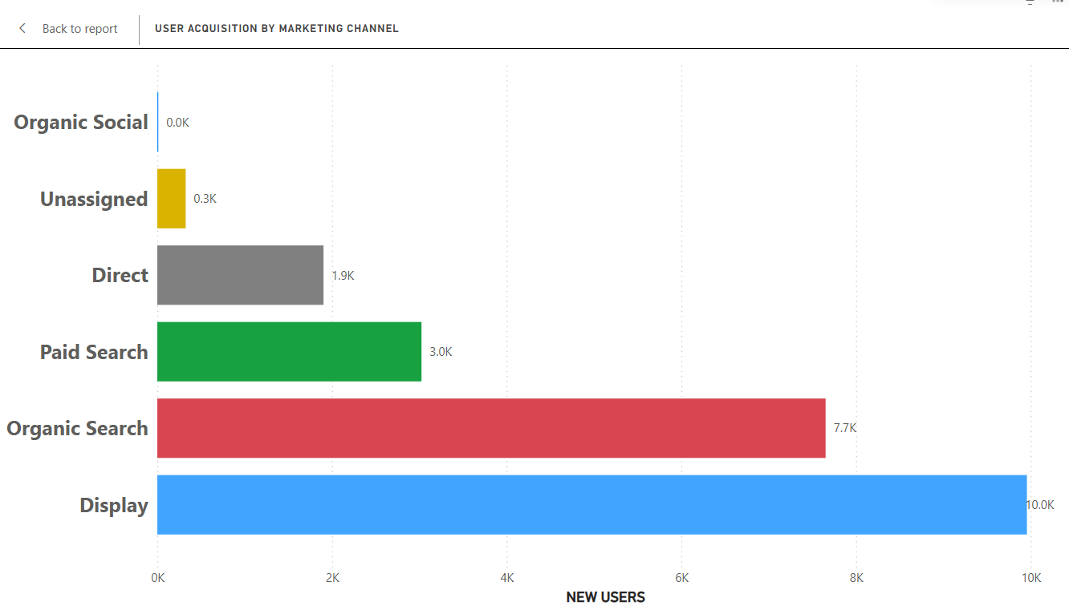

Fig 1: User acquisition performance showing Display as top source with 9,957 users but lower engagement compared to Organic Search's 81.4% rate.

**Display advertising** emerges as the volume leader, acquiring 43.5% of all new users (9,957 users), but demonstrates moderate engagement rates at 54.4%.  **Organic Search** shows superior user quality with the highest engagement rate at 81.4%, despite lower volume (7,652 users), indicating strong brand presence and content relevance.

**Paid Search** underperforms with only 47.4% engagement rate despite significant investment.

The data reveals a critical insight: while paid channels drive volume, organic channels deliver higher-value users who demonstrate greater long-term engagement potential.

**Paid Search** underperforms with only 47.4% engagement rate despite significant investment, suggesting keyword targeting and ad relevance optimization opportunities.

**Geographic Distribution Insights:**

India dominates the user landscape with 23,024 users (98% of total), reflecting the app's strong market penetration in the Indian digital ecosystem. **Bengaluru leads significantly** with 6,097 users and exceptional 76.9% engagement rate, followed by Patna (1,594 users, 44.1% engagement).  This concentration suggests successful localization strategies and market-product fit in Indian metropolitan areas.

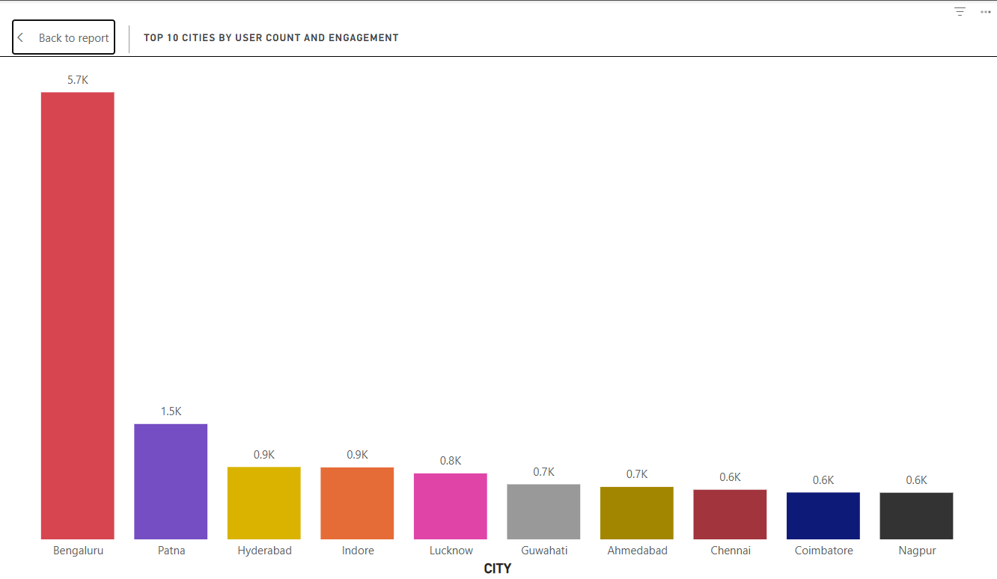

Fig2: User acquisition performance showing Display as top source with 9,957 users but lower engagement compared to Organic Search's 81.4% rate

The geographic analysis reveals **tier-1 city dominance** with major Indian cities representing the core user base. However, engagement rates vary significantly across cities, with Chennai (70.6%), Mysuru (63.0%), and Coimbatore (63.5%) showing strong performance,  indicating untapped optimization potential in similar markets.

**Demographic and User Behavior Analysis:**

**Age and Gender Distribution:**

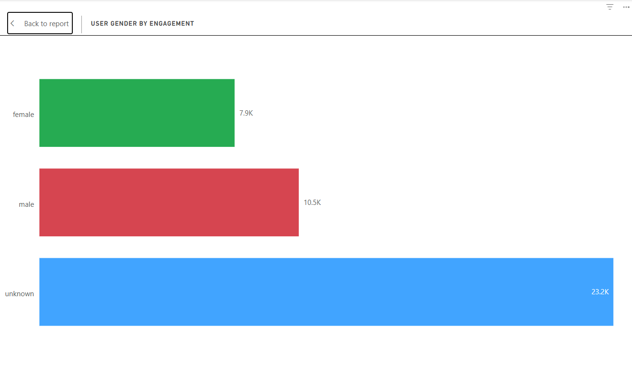

Fig 3: Demographics showing 54% unknown age users, with 18-24 being primary known age group and females having highest engagement at 63.8%.

The demographic analysis reveals significant **data collection gaps** with 54.3% of users having unknown age information and 51.9% unknown gender data. Among known demographics, the **18-24 age group** represents the largest segment (16.3%) with strong 69.5% engagement rates, indicating successful appeal to young adults entering the professional workforce.

**Female users demonstrate superior engagement** at 63.8% compared to males (54.3%), suggesting the app's content and features resonate particularly well with female professionals.

**Language and Interest Patterns:**

English dominates with 22,495 users (95.9% engagement rate), while Hindi follows with 586 users (40.6% engagement). This distribution reflects the app's positioning in the English-speaking professional market while highlighting potential for Hindi and regional language expansion.

**App Engagement and Usage Patterns**

**Screen Performance Analysis:**

**Flutter** emerges as the **primary engagement driver** with 156,708 views across 8,726 users (17.96 views per user), indicating robust core functionality usage. The MainActivity follows with 44,326 views but lower per-user engagement (4.94 views per user).

Critical user journey analysis reveals the feeds section as a key engagement point with 18,514 views across 4,358 users.

**Event Tracking and User Actions:**

Screen views dominate with 694,729 events, followed by notification interactions (125,146 receives, 70,128 dismissals). This pattern indicates strong passive engagement.

**Session management** shows healthy patterns with 61,163 session starts.

**Marketing Campaign Performance Analysis:**

**Campaign Efficiency Assessment & Conversion analysis:**

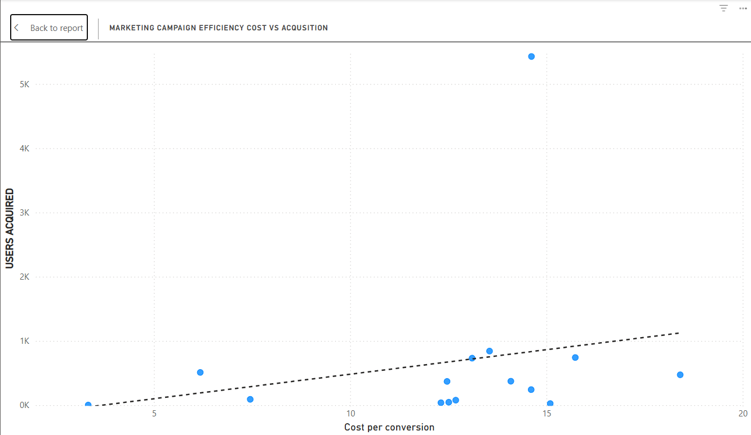

Fig 4: Campaign efficiency analysis showing Video-Internships as most cost-effective at $12.5 per user, while May-Shahid drives highest volume with 5,429 users

Marketing spend analysis reveals investment across 15 campaigns with varying performance levels. The "App Installation for May --Shahid" campaign leads in volume (5,429 users) but shows higher cost per user.

Campaign performance varies dramatically, with **conversion rates ranging from 125% to 260%**. Video-based campaigns consistently outperform static advertisements, indicating user preference for dynamic content.

**Conversion Funnel Analysis:**

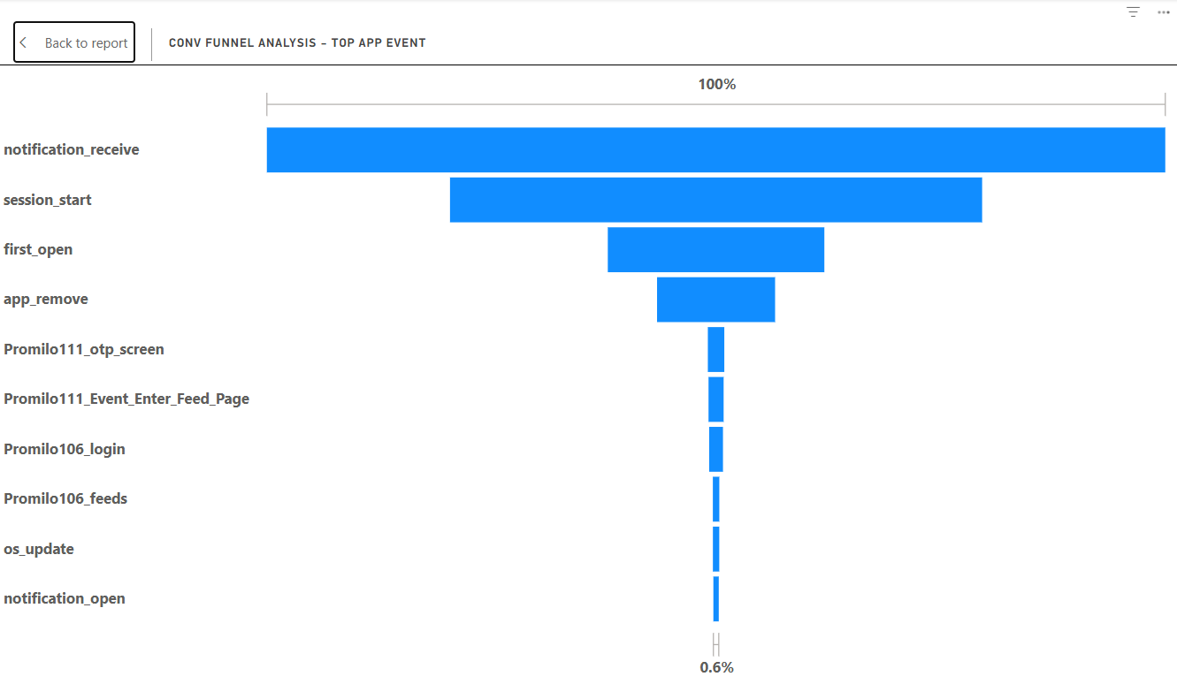

Fig5: Funnel analysis(without considering ‘not set’ and null value)

* Notification Engagement:
  + 100% of users received notifications, making it the widest entry point in the funnel.
  + However, not all notifications translated into app sessions.
* Session Start:
  + A significant drop is observed from notification_receive → session_start.
* First Open:
  + Only a subset of users proceeded to first_open after starting a session.
* App Remove:
  + A noticeable proportion of users uninstall the app after minimal interaction.
  + This is a red flag, indicating dissatisfaction, low perceived value, or technical issues.
* Deeper Engagement (Promilo Events):
  + Promilo111_otp_screen, login, and feed entry events show very low user transition rates.
* Notification Open:
  + At the very bottom, only 0.6% of users open notifications.
  + This indicates extremely low re-engagement through push notifications, limiting retention opportunities.

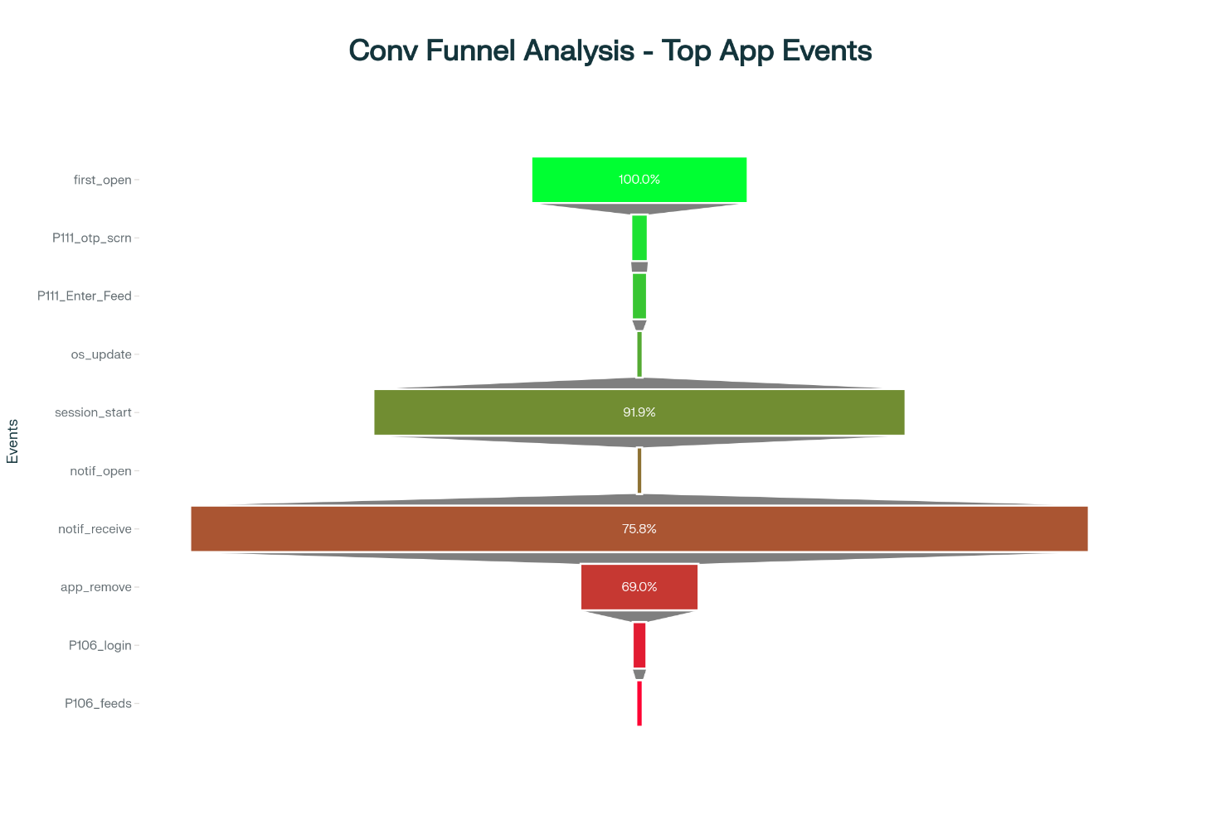

Fig 6: Conversion funnel showing 100% first_open conversion (considering not set & null, analysis with help of AI)

**Key funnel stages show:**

* Initial app interaction: 100% success
* Authentication completion: 27.7% conversion
* Feature engagement: 12.1% conversion
* Content consumption: Varies by feature

This analysis highlights **authentication friction** and **onboarding challenges** as primary optimization targets.

*\*\*Analysis Complete\*\**

**Recommendations for improving performance along getting more installations and engagement over App. & Website:**

**Long-term Strategic Roadmap:** Market Expansion Opportunities

* **Phase 1 (0-6 months):** Optimize existing funnel, enhance onboarding, and improve campaign efficiency**.**
* **Phase 2 (6-12 months):** Scale successful campaigns, expand to tier-2 Indian cities, and launch monetization features.
* **Phase 3 (12-18 months):** International expansion to similar markets, advanced personalization features, and enterprise offerings**.**

**Immediate Optimization requirements:**

1. **Authentication Process Redesign:**

Implement streamlined login options including Social media authentication, guest browsing capabilities. A Pop-up notification on website to signup/ Login on first visit.

1. **Content Discovery Optimization:**

Redesign the feeds interface to improve the conversion rate through personalized content recommendations, clearer navigation.

1. **Organic Search Investment:**Scale organic search efforts given the engagement rate by investing in SEO, content marketing, and app store optimization to capture high-quality users cost-effectively.
2. **Geographic Expansion Strategy:**  
   Leverage strong performance in tier-1 Indian cities to expand into similar markets while maintaining localization focus for cultural relevance and language preferences.
3. **User Data Enrichment:**  
   Implement progressive profiling to reduce the 54% unknown demographics rate through optional surveys, social integration, and incentivized data sharing.
4. **Target Audience:**  
   Based on user behaviour patterns and Indian market trends, implement a freemium model with premium features for high-engagement users, particularly targeting the strong female demographic.
5. **Enhance Notification-to-Action Conversion:**

Focus on notification_open improvements since it currently stands low.

Strengthen call-to-actions (CTAs) and ensure notifications align with user behaviour patterns.

1. **Boost Engagement with Core Feature:**
   * Encourage users to move beyond initial screens and explore feeds.
   * Introduce a Chat-Bot for support.
2. **Weekly updates and summary:**

An automated Email to share weekly updates and other things.

**CONCLUSION**

This analysis reveals a mobile application with strong market presence in India and significant optimization potential across user acquisition, engagement, and monetization. The combination of volume-driven acquisition channels and high-quality organic traffic provides a solid foundation for growth. However, critical funnel improvements and strategic campaign optimization could dramatically enhance user retention and revenue generation.

Success will depend on maintaining the strong organic growth foundation while optimizing paid acquisition channels, improving user onboarding experiences, and developing monetization strategies aligned with Indian market preferences and user behaviour patterns.